Prerequisites IBM Cloud Services

|  |  |
| --- | --- |
| Date | 16 November 2022 |
| Team ID | PNT2022TMID06071 |
| Project Name | Project – Smart solution for railways |
| Maximum Marks | 4 Marks |

Smart solution for railways

**VIGNESH D**

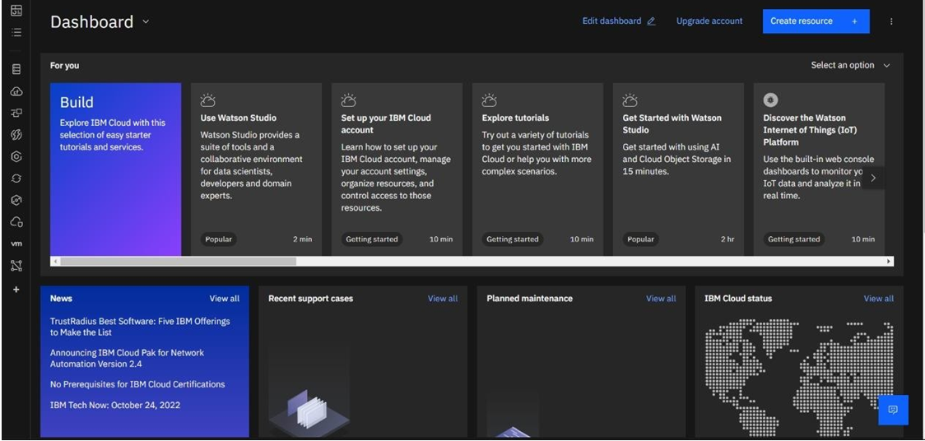

SRIVATSAN C



YUGESH M R



# SARATH CHANDRAN M

